PHARMA PREDICT: Machine Learning – Driven Medication and Inventory Management System

Abstract:
Pharma Predict is an advanced machine learning driven system that is designed to revolutionize medication and inventory management within pharmacies and healthcare institutions. The system enhanced patient care by integrating patient prescription patterns, seasonal trends. Leverages predictive analytics to optimize medicine stocks. integrates inventory management by real-time demand fore- casting. The system incorporates robust algorithms that learns from new data continuously and improve accuracy over the period of time. It also features user friendly interface for pharmacists and health care administrators that allows them to take informed decisions about inventory management, reduce risk of overstocking and medicine scarcity and streamline overall supply chain. Through the use of machine learning algorithms Pharma Predict aims to improve the operational efficiency and ensure patients receive the right medication and at the right moment. This innovation stands at the forefront of digital transformation of healthcare. This transformation offers a smart approach to managing pharmaceuticals.

INTRODUCTION:
In this papers we analyze different item-based recommendation generation algorithms.we look into different teqnicheques for computing item-item similarities and different techniques for obtaining recommendations from them
.One of the promising such technologies is collaborative filtering. The first challenge is to improve the scalability of the collaborative filtering algorithms.These algorithms are able to search tense of thousands of potencial neighbors in real-time but the demands of modern systems are to search tense of millions of potential neighbors.The second challenge is to improve the quality of the recommendations for the users.Users needs recommendations they can trust
to help them find items they will like.Users will “vote with their feet” by refusing to userrecommender systems that are not cosistently accurate for them. In this paper we address these issues of recommender systems by applying a different approach item-based algorithm.The bottle neck in conventional collaborative filtering algorithms is the search for neighbors among a large user population of potential neighbors.

Drug shortages are a global and complex issue having negative impacts on patients,pharmacists,and the broader health care system. Using sales data from 22 canadian pharmacies and historical drug storage data,we built machine learning models predicting shortages for the majority of the drugs in the most -dispensed interchangeable groups in canada.
When breaking drug shortages into four classes,we were able to correctly predict the shortage class with 69% accuracy and a kappa value of 0.44,one month in advance ,without access to inventory data from drug manufacturers and suppliers.We also predicted 59% of the shortages deemed to be most impactful. For pharmacists ,drug shortages can present serious challenges as well.In canada,when a drug with a particular Drug Identification Number(DIN) becomes unavailable,a pharmacist must find an alternative product within the same Interchangeable Group(IG) that comprises that DIN. Many countries have developed protocols that set expectations for drug shortages. In canada, such protocols were initially released in 2013 and updated in 2017 by Health Canada to coincide with the launch of Drug shortages canada , a publicly accessible and centralized database for Reporting drug shortages and discontinuations.
Our approach in this paper offers the application of Optical Character Recognition for the digitalization of handwritten medical prescriptions. It is determined that Doctor's handwritten prescriptions create a two-fold problem, one of the problems is unreadable writing and another inability of pharmacists to understand the medicine name. Our study will help in making pharmacist life easy at one end and making digitalized medical records maintenance easy. The field of OCR is still in the evolution phase. OCR is a branch of computer vision in computer science.
The general trend of research on inventory management has been usually using the MRP, as stated Rossi et. al (2017), who remark that around 75% of manufacturing companies use MRP as the main method for planning production. Since the introduction of the MRP, a wide variety of investigations have been developed, such as the proposal of Pooya et al. (2021), in which dynamic systems are used to reduce the impact of the
Bullwhipe effect produced by demand,and thus ,reduce production costs.a hybrid algorithm based on reinforcement learning and the inventory management methodology called DDMRP (Demand Driven Material Requirement Planning) to determine the optimal time to buy a certain product, and how much quantity should be requested. For this, the inventory management problem is formulated

as a Markov Decision Process where the environment with which the system interacts is designed from the concepts raised in the DDMRP methodology,and through the reinforcement learning algorithm-specifically , Q-learning.

References:
Sarwar et al.'s (2001) work on collaborative filtering techniques https://doi.org/10.1145/371920.372071
Clustering Techniques for patient segmentation: Research by Muyingo et al., (2011) https://epi-perspectives.biomedcentral.com/articles/10.1186/1742-5573-8-
3
Lops, Gemmis, and Semeraro (2011) on content-based filtering methods https://www.researchgate.net/publication/226098747
https://link.springer.com/article/10.1007/s10729-022-09627-y
Automated Validation Systems: Research papers like Akash Y. Nimbalkar (2024) combines OCR with Machine Learning models to automatically validate prescriptions.
https://link.springer.com/chapter/10.1007/978-981-97-1488-9_31
Inventory management using Machine Learning by Madhuri Javaregowda https://www.researchgate.net/publication/342529859
https://link.springer.com/article/10.1007/s10845-022-01982-5
Classification algorithms for inventory prioritization: study that applied decision trees and SVM in classifying drugs based on criticality and demand for inventory management is Quinlan (1993) a book (https://link.springer.com/article/10.1007/BF00993309)
and a research paper based on it (https://link.springer.com/chapter/10.1007/978- 981-99-8479-4_32 ).

Requirements Of Project:
The requirements of Pharma Predict are classified into Functional requirements and non-Functional Requirements. Given below is the detailed description of them:

Functional requirements
Sales Details: The system should allow employees to record sales including details of customer, medicine name, quantity sold.
Inventory Management: The system should auto update the stock availability of medicine after each sales transaction ensuring real-time inventory tracking. The system should provide notification and alerts if the updated stock is below the predefined threshold.
Sales Performance Tracking: The system shall provide tools for tracking and analysing sales, including metrics such as total sales, top-selling medicines, and sales trends over time.
Purchase: Employees should be able to record details of purchase orders for medicines from distributors, specifying details like quantity, and expiration dates.
Sales and Purchase Reports: The system should generate detailed reports on sales activities, and purchase activities including daily, weekly, and monthly summaries, as well as custom date ranges.
Medicine Reports: Comprehensive reports on medicine inventory, including stock levels, expiration dates and drug effects as well as drug uses.
Alerts: The system should generate alerts for employees when the expiration date of a medicine is approaching
User Authentication: The system should have a secure login mechanism with role-based access control, ensuring that Users can only access functions relevant to their roles.

Non-functional requirements:
Performance: The system should respond to user interactions within two or less seconds under normal operating conditions. The time taken to generate reports, should not exceed five seconds.
Reliability: In the event of a failure, the system should recover within five minutes with minimal data loss.

Security: All sensitive User data should be encrypted during transmission and storage. Role-based access control should be enforced. Passwords should be stored securely using industry-standard hashing algorithms.
Scalability: It should support the addition of new features and functionalities without requiring a complete system overhaul.
Availability: The system should be available 100% of the time during regular business hours. Any kind of scheduled maintenance should be communicated in advance, and efforts should be made to minimize downtime.
- Backup and Recovery: Customized and automated backups of the database and system configuration should be performed.
- Dependability: The system should be designed with built-in fault tolerance to minimize the impact of hardware or software failures.

Algorithms Used:
Drug Recommendation Systems:
Content-based Filtering for recommending medications based on specific features like drug composition, usage and similarity (similar patients).
Algorithms: K-Nearest Neighbour (KNN), Matrix Factorization (SVD, ALS).

Inventory Management:
Classification models to identify essential drugs and classify them for prioritized stock management.
Optimization Algorithms to determine optimal stock levels.
Algorithms: Decision Trees, Random Forests, Reinforcement learning for inventory optimization.

Automated Prescription Validation:
Image Recognition to analyse scanned prescriptions using image processing and classification.
Optical character Recognition to convert handwritten or printed text in prescription to digital data.
Algorithms: OCR tools, Support Vector Machines (SVM), Convolutional Neural Networks (CNN).

Personalized Medicine:
Clustering to group patients based on similar characteristics for personalized treatment.
Algorithms: K-Means clustering Bayesian Networks for probabilistic reasoning.

Literature Review
Paper-1 :Demand Forecasting for Medications

- Problem: Predicting the demand for medications is often challenging due to fluctuating patient needs, seasonal variations, disease outbreaks, and external factors like regulatory changes. Poor forecasting can lead to either medication shortages or excess inventory

Solution:
-Machine Learning Models: Several research papers propose using machine learning (ML) algorithms like time series forecasting (ARIMA, LSTM, etc.) and regression models to predict drug demand more accurately. These models can analyze historical sales data, patient treatment patterns, and even external data like weather or epidemiological trends.
Al-Driven Forecasting: Artificial intelligence (Al) techniques have been used to improve forecast accuracy, considering complex factors such as real-time patient needs, pharmacy purchase patterns, and supply chain delays..

References:
- "A Comparative Analysis of Predictive Models for Demand Forecasting in Pharmaceutical Supply Chain" (2020)
- "Predicting Medication Demand in Hospitals Using Artificial Neural Networks" (2019)

Paper-2: Inventory Management Issues
Problem: Managing inventory efficiently is crucial for maintaining the availability of medications. Excess stock leads to wastage (especially for short- life drugs), while stockouts can affect patient outcomes. Inefficient inventory management can also raise operating costs.

Solution:
Optimization Algorithms: Research shows that inventory control systems using optimization algorithms like Economic Order Quantity (EOQ), Just-In-Time (JIT) models, and stochastic inventory models help optimize stock levels.
Automated inventory Management Systems: Implementing cloud-based inventory management platforms integrated with predictive analytics and real- time tracking systems (using loT) can streamline stock monitoring.

References:
- "Inventory Control Models for Efficient Pharmaceutical Supply Chain Management" (2021)
- "Optimal Inventory Control with Stockout Risk for Perishable Products in the Pharmaceutical Sector" (2022)

Paper-3:Medication Expiry and Wastage
-Problem: Medicines often have a short shelf-life, leading to potential wastage if not used within the prescribed time. Inaccurate prediction of demand and poor inventory turnover can exacerbate this issue.

Solution:
Expiry Date Prediction Models: ML models can predict the probability of medication expiring based on inventory turnover rates and usage patterns. Some research suggests using reinforcement learning to prioritize inventory based on expiration dates to minimize wastage.
Dynamic Shelf-Life Management: Inventory management systems that monitor real-time stock levels and expiry dates can trigger automated alerts for stock rotation, minimizing wastage.

References:
- "Al-Based Expiration Date Prediction for Reducing Medication Wastage" (2020)
- "Optimizing Pharmaceutical Shelf-Life through Predictive Inventory Models" (2019)

Paper-4: Supply Chain Disruptions.
- Problem: Unpredictable supply chain disruptions (e.g., due to transportation issues, natural disasters, or regulatory delays) can cause medication shortages or delivery delays.

Solution:
Supply Chain Resilience Models: Research in this area focuses on creating resilient supply chains using blockchain for transparency, Al for risk prediction, and decentralized manufacturing to reduce dependence on single suppliers.
Inventory Buffer Systems: Advanced inventory management systems with buffer stock models can ensure availability even during supply chain disruptions.

References:
- "Al-Driven Supply Chain Resilience in the Pharmaceutical Industry" (2021)
- "Mitigating Supply Chain Risks for Pharmaceuticals Using Predictive Analytics" (2020)

Paper-5: Integration of Medication Data
- Problem: Lack of integration between healthcare systems and pharmacy inventory systems leads to inefficient medication tracking and replenishment processes.

Solution:
- Integrated Platforms: Several papers propose the use of integrated platforms that combine Electronic Health Records (EHR) with inventory management systems to track real-time usage data. This integration can lead to better synchronization between patient demand and inventory availability.
-Blockchain for Transparency: Blockchain-based solutions for traceability and transparency can be used to ensure that medication flow, from production to dispensing, is properly documented and visible to all stakeholders.

References:
- "Blockchain for Integrated Pharmaceutical Supply Chain Management" (2020)
- "Enhancing Medication Tracking through EHR and Inventory System Integration" (2019)

Paper-6:Regulatory Compliance in Inventory Systems
- Problem: Managing inventory while staying compliant with regulatory standards (e.g., FDA regulations) can be complex. Failing to comply with these standards can lead to legal issues and product recalls.

Solution:
-Regulatory Compliance Software: Inventory management systems that include built-in features for tracking regulatory compliance, such as automated auditing, labeling, and reporting, can simplify the compliance process. Some systems also integrate Al to proactively flag potential compliance risks.

References:
- "Al in Regulatory Compliance: A Framework for Pharmaceutical Inventory Systems" (2021)
- "Managing FDA Compliance in Pharmaceutical Inventory through Automated Systems" (2018)

Paper-7: Data Quality and Standardization
-Problem: Poor data quality in medication demand and inventory systems (e.g., incorrect or incomplete data) can lead to inefficiencies in prediction and management.

-Solution:
Data Standardization Techniques: Research emphasizes the importance of standardizing data inputs, such as using common drug identification systems and coding standards. Machine learning models are often dependent on clean, high- quality data, making standardization critical.
Data Cleaning Algorithms: Al algorithms can be employed to clean and standardize data, identifying and correcting inconsistencies.

References:
- "Data Standardization and Quality Assurance in Pharmaceutical Inventory Systems" (2019)
- "The Role of Al in Ensuring Data Integrity in Pharmaceutical Supply Chains" (2021)

Summary:
The primary research-based solutions for medication prediction and inventory management include. machine learning algorithms for demand forecasting, optimization techniques for inventory control, Al-driven platforms for reducing wastage, and blockchain technologies for enhancing transparency. Improved data integration and regulatory compliance mechanisms are also pivotal for better management systems.

S.no | Research links | Papers methodology
1. | https://doi.org/10.1145/371920.372071 | Sarwar et al.'s (2001) work on collaborative filtering techniques
2. | https://www.researchgate.net/publication/2 26098747 | Lops, Gemmis, and Semeraro (2011) on content-based filtering methods
3. | https://link.springer.com/article/10.1007/s1 0729-022-09627-y | Machine Learning in Inventory Management: Study works by Raman Pall and Yvan Gauthier (2023)
4. | https://link.springer.com/chapter/10.1007/9 78-981-99-1620-7_4 | OCR and Image Recognition: Study papers like Sethi et al. on the application of OCR in digitizing handwritten prescription, and CNN based models for image recognition in health care.
5. | https://link.springer.com/chapter/10.1007/9 78-981-97-1488-9_31 | Reinforcement Learning in Inventory control: research by Carlos Cuartas and Jose  Aguilar (2022) on

 |  | reinforcement learning and it’s applications in optimizing pharmacy inventory management.
6. | https://www.researchgate.net/publication/3 42529859 | Inventory management using Machine Learning by Madhuri Javaregowda
7. | (https://link.springer.com/article/10.1007/B F00993309 | Classification algorithms for inventory prioritization: study that applied decision trees and SVM in classifying drugs based on criticality and demand for inventory management is Quinlan (1993) a book
8. | (https://link.springer.com/chapter/10.1007/9 78-981-99-8479-4_32 ). | einforcement learning algorithms can dynamically impact inventory levels ased on changing demand hence improving pharmacy profits.
9. | https://epi- perspectives.biomedcentral.com/articles/10. 1186/1742-5573-8-3 | clustering algorithms help in identifying groups of patients with similar behaviours, allowing for the development of personalised strategies.

Drug Recommendation:
Sarwar et al.'s (2001) work on collaborative filtering techniques https://doi.org/10.1145/371920.372071

Lops, Gemmis, and Semeraro (2011) on content-based filtering methods https://www.researchgate.net/publication/226098747 have focused on drug recommendations based on patient medical history and drug profiles.
Key Insights: The application of collaborative filtering can enhance personalized drug recommendations by learning from the prescribing patterns of similar patients. Content-based filtering, when combined with patient-specific data (e.g., genetic profiles, allergies), can tailor medication choices effectively.

Predictive Analysis:
Box and Jenkins, 1970 work on use of time series models like ARIMA and LSTM in predicting demand for drugs.
Machine Learning in Inventory Management: Study works by Raman Pall and Yvan Gauthier (2023)
https://link.springer.com/article/10.1007/s10729-022-09627-y that discuss the integration of regression models and decision trees in predicting inventory needs and managing supply chains.
Key Insights:
Machine learning models, particularly LSTM networks, are effective in handling temporal data for drug demand forecasting, providing pharmacies with actionable insights. Regression models can be instrumental in inventory optimization, helping to minimize stockouts and overstock situations.

Automated Prescription Validation
OCR and Image Recognition: Study papers like Sethi et al. on the application of OCR in digitizing handwritten prescription, and CNN based models for image recognition in health care.
https://link.springer.com/chapter/10.1007/978-981-99-1620-7_4 Automated Validation Systems: Research papers like Akash Y. Nimbalkar
(2024) combines OCR with Machine Learning models to automatically validate
prescriptions.
https://link.springer.com/chapter/10.1007/978-981-97-1488-9_31 Key Insights:
Integration of OCR with Machine Learning models can significantly reduce errors in prescriptions processing.

Convolutional Neural Networks (CNN) are effective in recognizing and validating handwritten Prescriptions.

Inventory Management Optimization
Reinforcement Learning in Inventory control: research by Carlos Cuartas and Jose Aguilar (2022) on reinforcement learning and it’s applications in optimizing pharmacy inventory management.
https://link.springer.com/article/10.1007/s10845-022-01982-5
Inventory management using Machine Learning by Madhuri Javaregowda https://www.researchgate.net/publication/342529859
Classification algorithms for inventory prioritization: study that applied decision trees and SVM in classifying drugs based on criticality and demand for inventory management is Quinlan (1993) a book (https://link.springer.com/article/10.1007/BF00993309)
and a research paper based on it (https://link.springer.com/chapter/10.1007/978- 981-99-8479-4_32 ).
Key Insights
Reinforcement learning algorithms can dynamically impact inventory levels ased on changing demand hence improving pharmacy profits.
Classification models aid in the prioritisation of drug stocks ensures that essential medicines are always available.

Grouping Patients
Clustering Techniques for patient segmentation: Research by Muyingo et al., (2011) https://epi-perspectives.biomedcentral.com/articles/10.1186/1742-5573-8- 3 on clustering methods to segment patients based on adherence patterns.
Key Insights
Clustering algorithms help in identifying groups of patients with similar behaviours, allowing for the development of personalised strategies.

UML DIAGRAMS:

FLOW CHART:
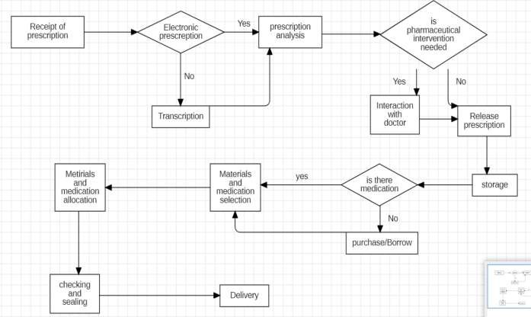

Activity diagram:

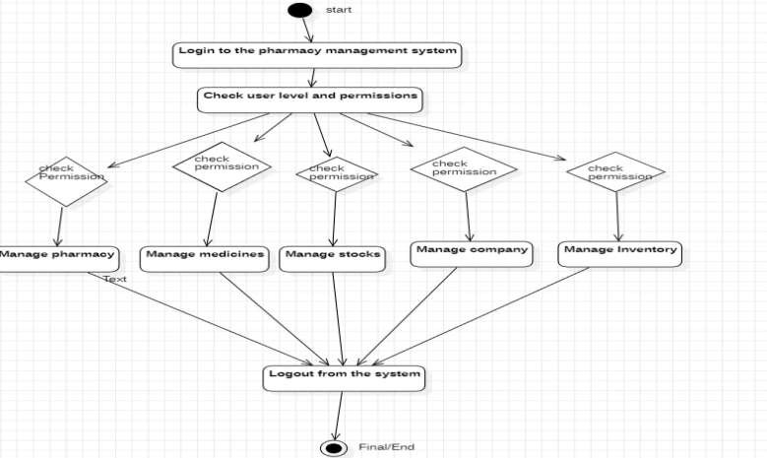

Sequence diagram:
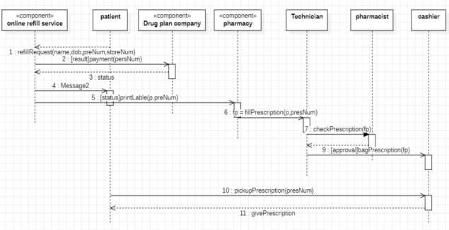

Class diagram:

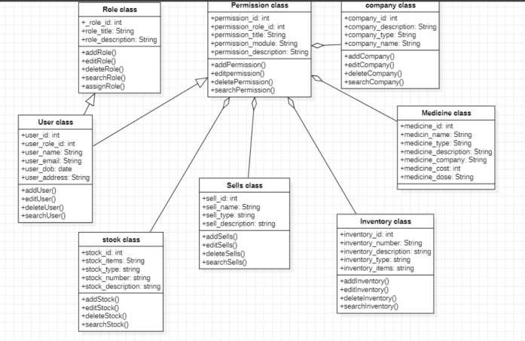

Use case diagram:

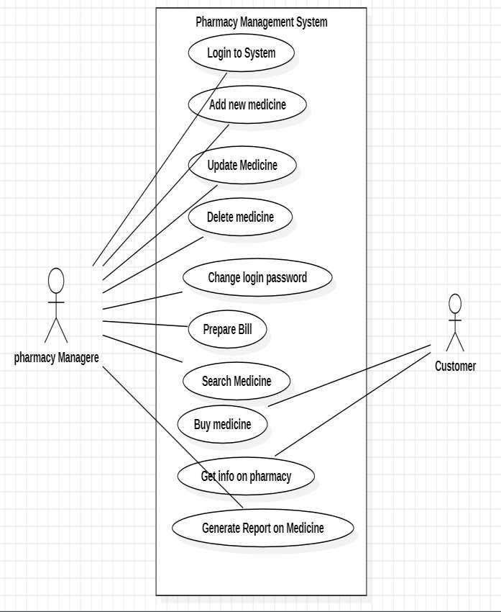

USE CASE SCENARIOS:

USE CASE | ACTOR | DESCRIPTION
Login to System | Pharmacy Manager | The pharmacy manager logs into the system to access functionalities.
Add new Medicine | Pharmacy Manager | The pharmacy manager adds new medicine  details to the system.
Update Medicine | Pharmacy Manager | The pharmacy manager updates information  about existing medicines.
Delete Medicine | Pharmacy Manager | The pharmacy manager deletes a medicine from  the system.
Change Login Password | Pharmacy Manager | The pharmacy manager changes their login  password for security purposes.
Prepare BIll | Pharmacy Manager | The pharmacy manager prepares a bill for customer purchases
Search Medicine | Pharmacy Manager, customer | Both the manager and customer search for  available medicines.
Buy Medicine | Customer | The customer buys medicine from the  pharmacy.
Get info of Pharmacy | Customer | The customer retrieves information about the pharmacy (location,  services, etc).
Generate Report on Medicine | Pharmacy Manager | The pharmacy manager generates reports on stock. sales, and other  data

Data flow diagram:
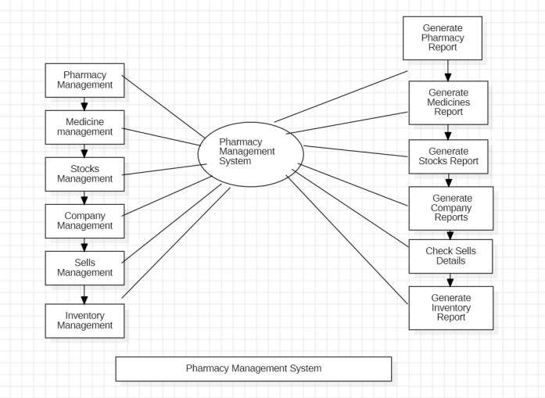
State chart diagram:
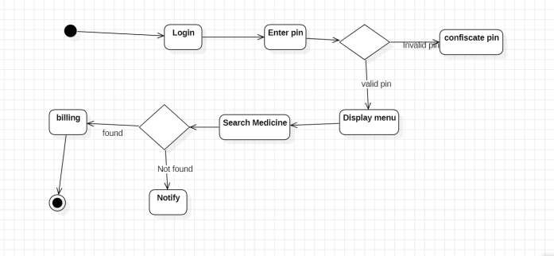

Component diagram:

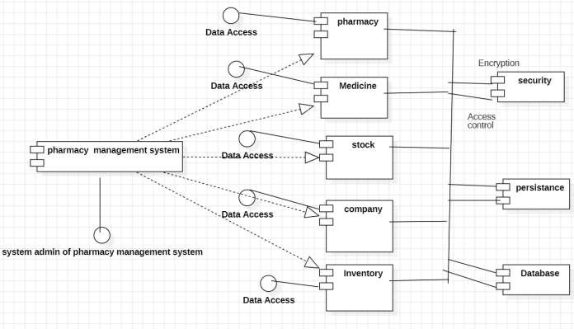

Deployment Diagram:
